A Comparative Study of Global and Bangladeshi Student Dropout Prediction Using Machine Learning
Raywana Binta Rafiq Sadia  Department of Information Technology & Management (ITM)  Daffodil International University, Savar, Dhaka, Bangladesh | Tithi Tarafdar  Department of Information Technology & Management (ITM)  Daffodil International University, Savar, Dhaka, Bangladesh

Supervisor: Dr. Nusrat Jahan | Associate Professor & Department Head, Information Technology & Management
Daffodil International University, Bangladesh

ABSTRACT
Dropout is one of the most universal issues in higher education, with impacts on academic achievement, institutional efficiency, and socio-economic impacts. The study aims to explore students' dropout issues using machine learning techniques on two datasets: one global dataset with about 10,000 students (Kaggle) and one local dataset with 256 university students from Savar, Dhaka of Bangladesh.The same machine learning pipeline was used to make meaningful cross-context comparisons. Eight models Random Forest, Logistic Regression, SVM, XGBoost, kNN, Decision Tree, a tuned XGBoost and a Hybrid Voting Classifier were used for the global dataset. Six models namely Random Forest,Logistic Regression, XGBoost (Linear and Tree), SVM, Gradient Boosting were used for the Bangladesh dataset. To prevent data leakage, preprocessing was only performed on the training data and included cleaning, encoding, scaling, and SMOTE balancing. The models were assessed by Accuracy, Precision, Recall, F1-score and ROC-AUC and key predictors were identified using SHAP analysis.The results showed that ensemble and boosting models perform better than the traditional ones. In both situations, academic achievement and attendance were good predictors. Socio-economic hardship, financial stress, marriage pressure and feelings of loneliness due to urban migration had a significant association with dropout in Bangladesh while the association for global dropout was stronger with engagement and institutional interactions.This study offers a replicable and interpretable blueprint to understand dropout, and has practical implications for early intervention and educational policy in Bangladesh and its context.
Keywords — Student Dropout Prediction, Machine Learning, SHAP, Educational Data Mining, XGBoost, Random Forest, Bangladesh, Comparative Analysis, Explainable AI, Student Retention, SMOTE

I. INTRODUCTION
Student drop-out is one of the most pervasive problems in the higher education sector and impacts on academic attainment, institutional operations and the wider socio-economic consequences. This research aims to study student dropout with the help of machine learning techniques and two datasets are used in this study: The first one is, global dataset with about 10,000 students (Kaggle) and another is Bangladeshi dataset with 256 students from a university in Savar, Dhaka.

The same machine learning pipeline was used to enable meaningful comparisons across contexts. Eight models (Random Forest, Logistic Regression, SVM, XGBoost, kNN, Decision Tree, a tuned XGBoost and Hybrid Voting Classifier) were considered for the evaluation of the global dataset. Random Forest, Logistic Regression, XGBoost (Linear and Tree), SVM, Gradient Boosting were the six models used with the Bangladesh dataset. The data was then preprocessed using only techniques that were applied to the training data to prevent data leakage: cleaning, encoding, scaling, SMOTE balancing. Models were evaluated based on their Accuracy, Precision, Recall, F1-score and ROC-AUC metrics and the key predictor features were identified using SHAP analysis.

The results show that ensemble models and boosting models are better than traditional classifiers. For both sets of data, academic performance and attendance were good predictors. The socio-economic hardship, financial stress, pressure on marriage, and loneliness due to urban migration has a significant influence on drop out in Bangladesh, whereas in other countries, drop out has been more strongly associated with engagement and institutional interactions.

The study provides a replicable and meaningful framework for addressing dropout and provides actionable insights for early interventions and education policy in Bangladesh and beyond.

A. Research Objectives
- This aims to construct a globally reproducible machine learning pipeline which would adhere to one global benchmark dataset from Kaggle, as well as an input dataset specific to Bangladeshi students through experimental conditions where models are rightly contrasted. The global data set was used to evaluate a total of eight models: Random Forest, Logistic Regression, SVM (suport vector machine), XGBoost, tuned KNN model, Decision Tree (DT), tuned XGBoost and a hybrid voting classifier. Logistic Regression, Random forest, XGBoost/ HGB + Gradient Boosting SVM (support vector machine) & CatBoost/ HGB-v2 based Bangladeshi dataset.
- SHAP-based explainability on student dropout predictors on both datasets to identify and understand Bangladesh-socio-cultural drivers such as CGPA trajectory, marital pressure, financial stress, loneliness due to urban migration.
- To develop a comparison-based ML framework based on an interpretable language which can support local, information and context sensitive policy making and student support for educational decision makers in Bangladesh (and more broadly in similar university contexts in developing countries).
B. Research Contributions
- A closed loop and reproducible ML pipeline for global and local dataset for Bangladesh.
- The study examines the predictors of potential dropouts in the context of financial pressure, early marriage and migration stress using SHAP appeal-based contextual analysis in Bangladesh.
- The framework of equivalent ML for systematically dropping out predictors for global vs goes to Bangladeshi students.
- Practical suggestions for university counsellors, administrators and policy makers in similar south Asian contexts .
II. RELATED WORK
A. Global Perspectives on Dropout Prediction
Over the past decade, the use of machine learning for predicting student dropout has become increasingly popular, supported by both the rising availability of institutional data and simpler computational tools. One of the first systematic studies, Prenkaj et al. Reference [9] provided a detailed study on different ML strategies used on dropout prediction in online classes, where reports showed about 40-80% dropout rates in MOOCs and >10-20% retention rate drop compared to conventional university-based classes. The survey started with demographic and grade-based models, then moved on to sequence-labelling models based on clickstream and forum data, and finally to temporal network models that capture the dynamics of peer interactions.
Realinho et al. 2019 [8] published a comprehensive empirical benchmark dataset that includes data for 4,424 undergraduate students from 17 different study programs of a Portuguese university, from the academic year 2008/2009 to 2018/2019. They used the demographic, socioeconomic, macroeconomic and academic performance features in their analysis. They used a machine learning classification to discriminate dropout, enrolled and graduated students. The most important predictors for the entire follow-up period were the average first semester grades (10.64/20) and course approval rate 4.71 of enrolled subjects/6.27 which allowed for individual intervention and significant classification accuracy.
Kabathova and Drlik investigated dropout in a small e-learning environment of 261 students of Database Systems in 4 academic years, with an overall dropout rate of 21.92%. Random Forest got 93% accuracy (recall = 96%, precision = 86%, F1-score=91%) and AUC-ROC of 0.968 which is higher than other classification algorithms used (Logistic regression, SVM, Decision Tree, Naive Bayes writedown in manager). It demonstrated that good characteristics of small data sets can be effective in identifying risk.
Park and Yoo [12] predicted dropout in the first 7 years of study for learners from 98,685 students. They were able to train their Random Forest model to achieve 96% accuracy, 76% recall and AUC of.95 which is considerably better than Deep Neural Networks (85% accuracy, 39% recall) in this scenario. In a tracking study, students' activity in relation to the results of the regular assessment weekly measure indicated that the method of combining data from the online platform and traditional academic performance indicators could be used to provide quick feedback on progress.
Baranyi et al. [13] only used pre-enrollment features from the Budapest University of Technology to predict the final performance using deep neural networks. The best fully connected neural network found was with an accuracy of 72.4% (AUC = 0.771), which was slightly better than XGBoost (70.7%) and Random Forest (67.3%). Among the features explored, years since high school graduation and university entrance scores were the strongest pre-enrollment predictors, as revealed by SHAP analysis.SHAP analysis revealed years since high school graduation and university entrance scores as the strongest pre-enrollment predictors among the features explored.

B. Advanced ML and Ensemble Approaches
Borges et al. [1] created a class dropout prediction system at the University of Coimbra, which was evaluated using more than 1.6 million records and several algorithms such as Naive Bayes, KNN, Decision Tree, Random Forest and XGBoost. The best overall performance was achieved by XGBoost with a recall of 0.996 and an AUC-ROC of 0.955 on end-of-term data. The authors also created BATINA OnBoard, a real-time educational support tool that incorporates the outputs of predictive models for proactive student retention management.
Pecuchova and Drlik [2][4] suggested ensemble-based approaches based on the data collected from Computer Science students in blended learning settings in the Moodle LMS. The ensemble models performed best with accuracy values of 88.49%, 91.34%, 94.24% and 97.06% in four stages of prediction of course-quarters, with ensemble models outperforming individual classifiers by 2–4%. The test scores, assignment completion and attempt counts were the most influential predictors and the third course quarter was found to be the best time for intervention.
Zanellati et al. [3] tested 364 models on a dataset of 44,875 Italian university students, comparing the performance of the Feature Tokenizer Transformer (FTT) with Random Forest. FTT performed slightly better than Random Forest (85% accuracy, 80% sensitivity) at 87% accuracy and 81% sensitivity at 12 months post-enrollment. The best predictors of dropping out were ECTS credits earned and weighted average marks. The study also used fairness analysis to guarantee ethical reliability of predictions.
Villar and De Andrade [5] directly compared supervised ML algorithms using 4,424 student records that included 35 academic, socioeconomic and demographic features. Their study showed that the boosting algorithms, specifically CatBoost and LightGBM, with SMOTE and ADASYN for class imbalance correction, yielded the best F1-scores for the dropout class (0.88) and AUC values exceeding 0.95, respectively. SMOTE was better than ADASYN in dealing with class imbalance. The main drivers of dropping out were identified through SHAP analysis as being curricular units approved, grade, scholarship status, and tuition fee status.
Krüger et al. [6] built an explainable ML model using 137 academic, temporal, and socioeconomic features and 299,722 records from 19 private schools in Brazil. XGBoost's AUC-PR scores rose from 0.3822 in the first trimester to 0.8950 in the third, while the precision and recall were 95.23% and 93.93% respectively in the third trimester. Cumulative grades and trimester performance differentials were determined to be the most informative predictors through SHAP analysis, and a PowerBI dashboard was created to visualize the probability of dropping out for institutional use.
Mustofa et al. [7] proposed a Hybrid Logistic Regression and Neural Network (HLRNN) model that obtained 96% accuracy, precision, and recall on a dataset of 4424 students. The most important dropout factors identified by the SHAP and LIME explainability analyses were gender, debt status, displacement, parental background, scholarship status, and tuition fee condition. Kim et al. [15] validated a Hybrid Student Dropout Prediction (SDP) system on 67,060 records with precision ranging from 0.819–0.947, recall from 0.752–0.790, and F1-scores of 0.786–0.850, along with a Dropout Reason Classification module for targeted counseling intervention. Vaarma and Li [14] investigated Finnish higher education in 98,685 students, and found that Random Forest outperformed the others with an accuracy of 96% and AUC of 0.95, highlighting the importance of first semester grades, cumulative GPA and LMS activity for early identification of risk.

C. Summary of Related Work
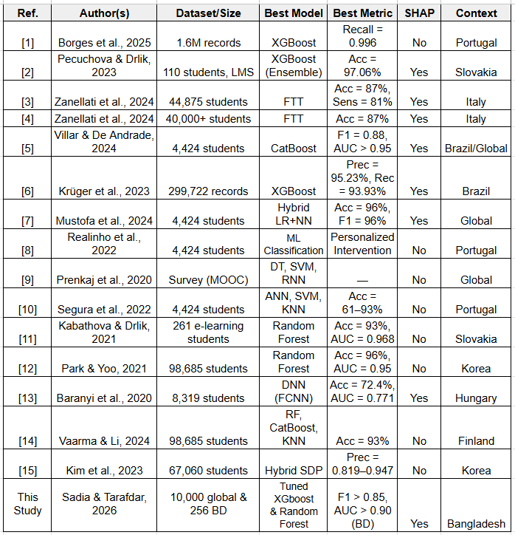
Table I. Summary of related works in student dropout prediction using machine learning.

D. Research Gaps
Through a comprehensive review of current literature, several key gaps are identified. To our knowledge, 1 there has been no direct controlled comparison between a locally-consumed Bangladeshi dataset collected from universities and the popular benchmark datasets commonly used with respect to the same ML pipeline. Nevertheless, the socio-cultural specificity of Bangladeshi dropout risk (such as pressure to marry-off early, financial hardship among 1st Generation learners and rural-to-urban migration stress) has not previously been measured empirically using ML techniques. Second, even though SHAP-based explainability is utilized in few recent works [2, 5, 6, 7], there are few applications in developing-country higher education. Third, the problematic behavior of data leakage in applying SMOTE to oversampling on only the training data is handled inconsistently in the literature as well causing reproducibility problems. Each of these gaps is directly addressed within the design, implementation and analytical approach of the present study.

III. DATASET DESCRIPTION
This study employs two distinct datasets. The Bangladeshi dataset constitutes the primary contribution, while the Kaggle global dataset provides a comparative benchmark.
A. Global Dataset (Kaggle Benchmark)
Global Dataset ─ Global dataset is a global public dataset available on Kaggle and has ~10,000 records about students from different international academic settings. These are among the demographic factors (age, gender, parental education), academic factors (GPA, study hours per day), financial factors (family income, savings made prior to semesters, and scholarship) and engagement.The classification setting has a binary dropout label:(dropout = 1, no dropout=0). Family_Income was created using median imputation and Stress_Index and Parental_Education were created using mode imputation.

B. Bangladeshi Dataset (Primary Dataset)
The Bangladeshi data was gathered using a structured survey from 256 university students at private universities in Savar, Dhaka. To ensure maximum accessibility and response accuracy, the survey instrument was bilingual (English and Bengali). It includes 25 features from academic, financial and socio-cultural fields which are relevant to the peri-urban context of Dhaka. No administrative dropout label was available, so a synthetic but domain-validated binary target was created with a risk-weighted probability function (logistic sigmoid, scale factor 0.35, seed = 42) that resulted in a realistic dropout rate of ~15%. This approach is repeatable and well documented in the codebase attached.
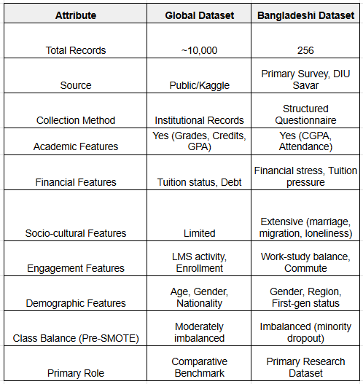
TABLE II: DATASET COMPARISON — GLOBAL VS. BANGLADESHI

IV. METHODOLOGY
A. Research Design and Comparative Framework
In this research, the student dropout problem is investigated following a parallel comparative machine learning method in two different educational systems [3, 5, 6, 14]. This methodology is not identical to a pipeline for both datasets, but rather a systematic and philosophically adequate approach, appropriate to the context. The basic concepts of both pipelines are the same: systematic data preprocessing, class imbalance correction, a shared set of evaluation metrics, consensus-based feature importance ranking, and explainability via SHAP. Any changes in the specifics of implementation are intentional and appropriate to the data sets, however, and account for variations in scale, structure, availability of labels and socio-cultural richness among the two data sets. The Kaggle data set is global and has about 10,000 records, which are already standardized, and the label is already provided for each record, so more aggressive modelling techniques such as hyperparameter tuning and the construction of hybrid ensembles can be used. The Bangladeshi primary data set consists of 256 field survey responses from students in Savar, Dhaka, leading to a more conservative approach to pipeline, prioritizing hyperparameter tuning for overfitting prevention, feature engineering, and contextual interpretability over model complexity. The evaluation is carried out methodologically and according to the nature of each dataset, and a common framework for evaluation facilitates the comparison of results across contexts in a principled way [5, 9, 14].

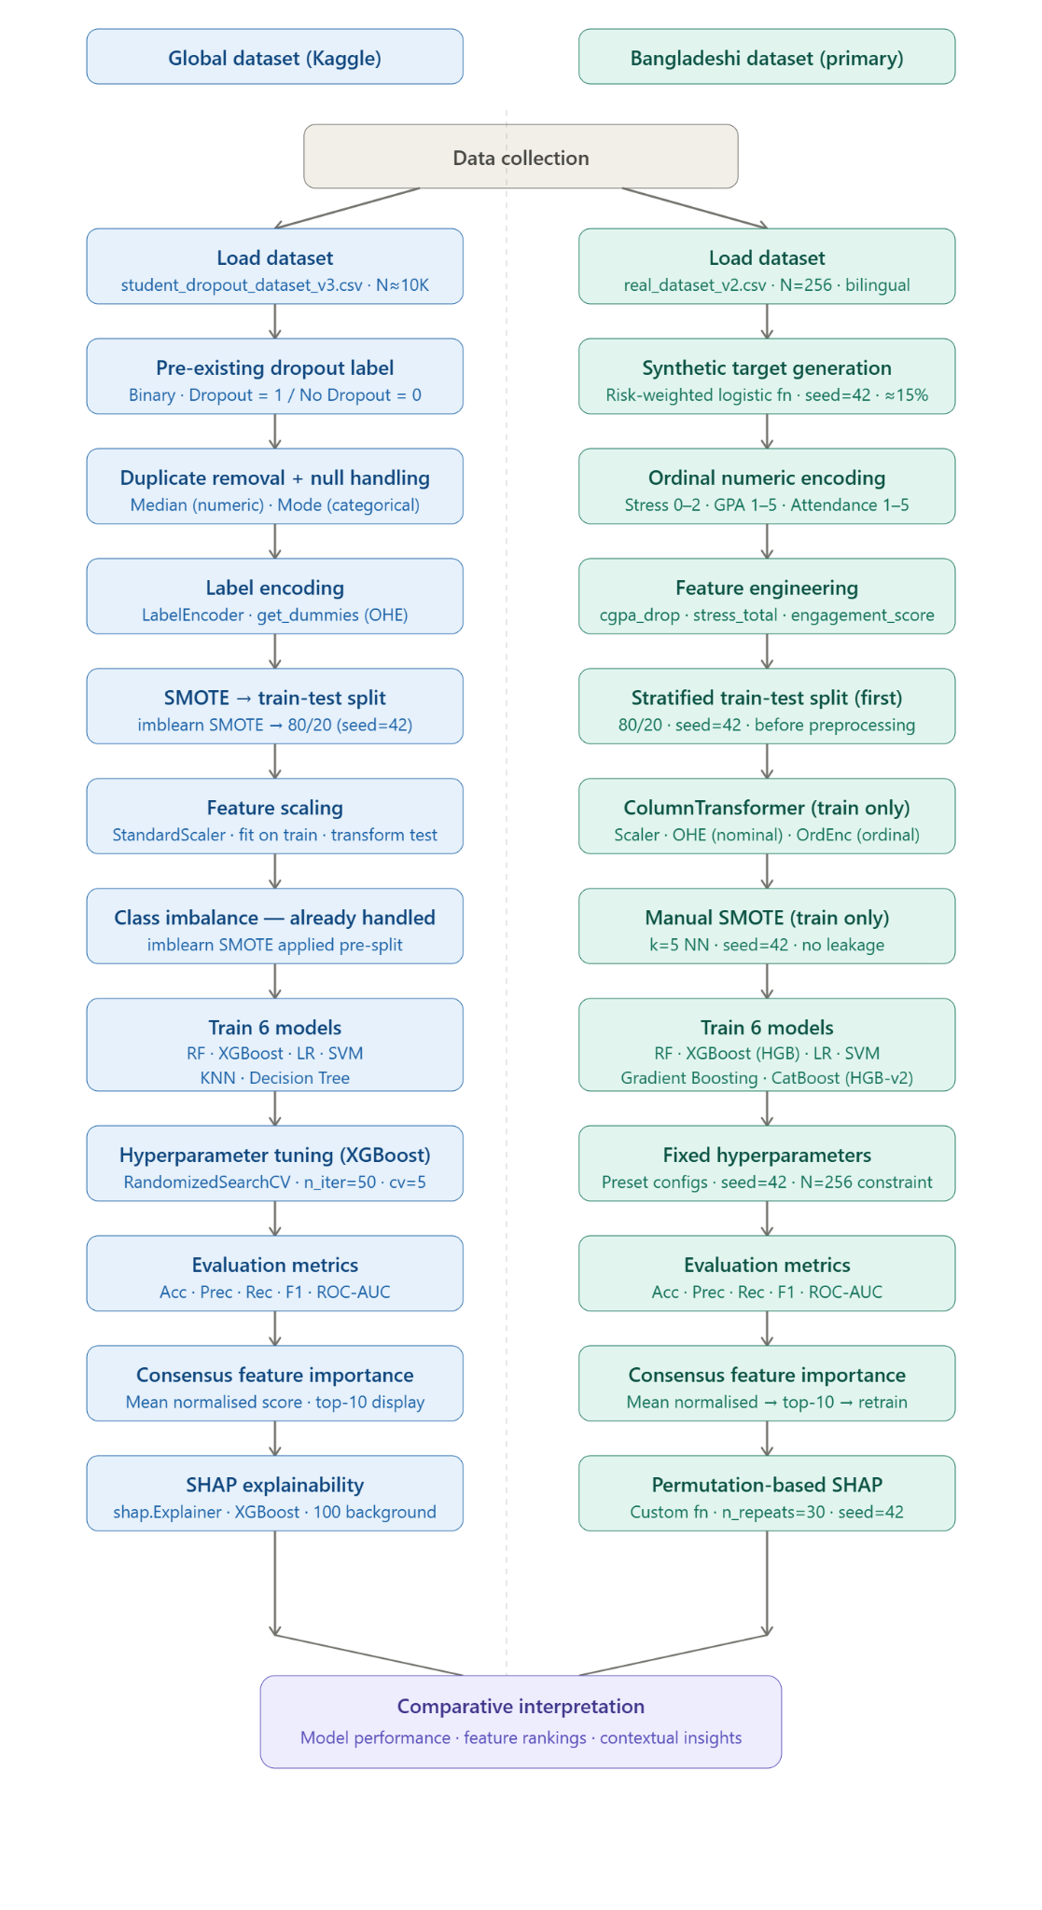
FIGURE 1: Proposed Machine Learning Pipeline for Comparative Student Dropout Prediction
A.1 Comparative Graphical Analysis of Machine Learning Results

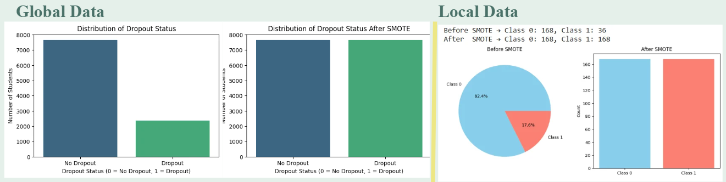
[FIGURE 2: Class Distribution Before and After SMOTE Balancing (Bangladeshi Dataset)]
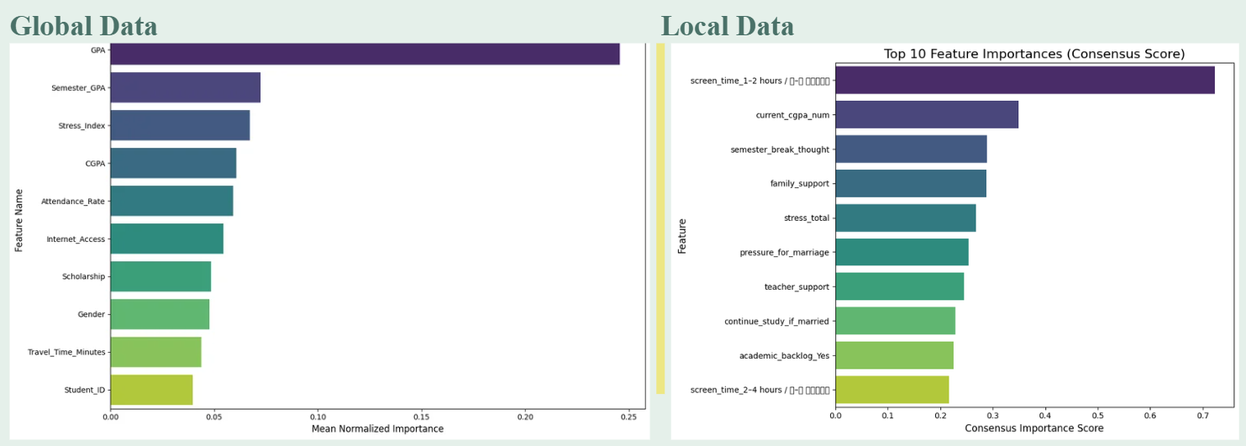
[FIGURE 3: Comparative Top-10 Feature Importance: Global Dataset vs. Bangladeshi Dataset]

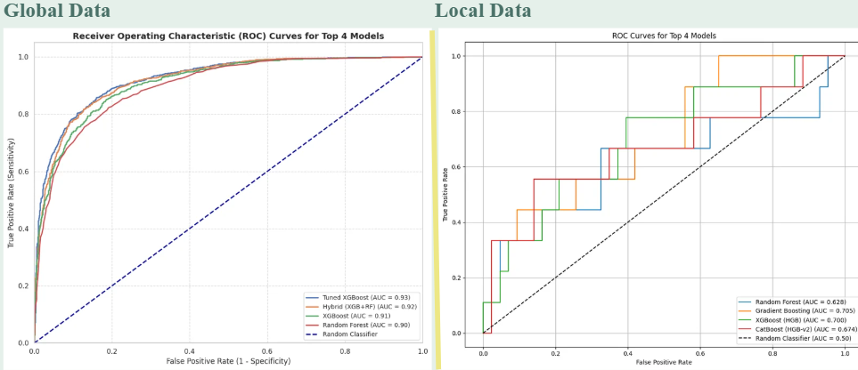
[FIGURE 4: ROC Curves for All Six Models — Global and Bangladeshi Datasets]

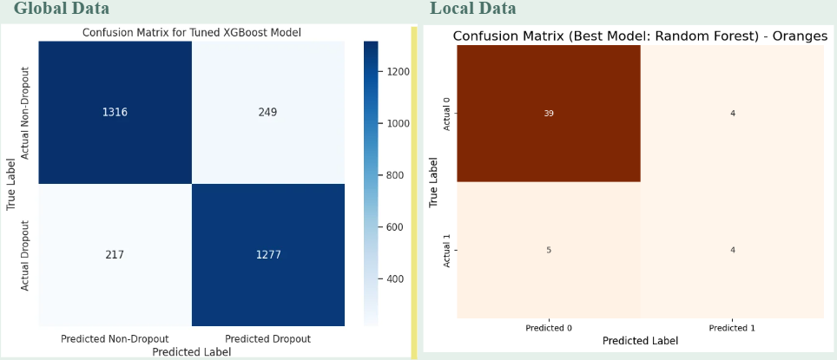
[FIGURE 5: Confusion Matrices — Best-Performing Model (XGBoost) on Both Datasets]

B. Dataset Preparation of Global Kaggle Dataset
B.1 Data Loading and Inspection
The entire dataset was downloaded from a public repository from Kaggle with approximately 10K students from various academic environments around the world. Structural soundness of the data set was investigated during loading, such as what kind of variables are used, the distribution of the variables and the presence of any outlier entries. There was a binary target variable that did not require to be derived, Dropout [8, 10, 14] where 1 represented a dropout event and 0 represented continued enrolment.
B.2 Duplicate Detection and Removal
Pandas' duplicated() function was used to examine the data and remove any duplicate rows. The duplicates were identified before any further processing was done to avoid over-optimized model performance due to repeated observations in both train and test sets.
B.3 Missing Value Handling
The analysis revealed that there were missing values in four columns. The missing values in the numerical columns Family_Income, Study_Hours_per_Day, and Stress_Index were filled with the median of each column, a good method for skewed distributions [5, 6] that is common in socio-economic data. The categorical variable Parental_Education was imputed by the column mode, which is the most representative category without creating new category levels. The numerical columns Family_Income, Study_Hours_per_Day and Stress_Index were filled with the median of the corresponding columns, which is a method that is appropriate for data with skewed distributions, common in socio-economic data [5, 6]. The column mode was used for imputation of the categorical column Parental_Education, which was the most representative category without adding new category levels.
B.4 Feature Encoding
The categorical variables were systematically encoded into numeric form, as appropriate for machine processing. For all object-type columns used, we applied LabelEncoder, which provided ordinal integer mappings. Subsequently, pd. We encoded nominal categorical features using one-hot encoding (i.e., performed with the pd.get_dummies() function which creates dummy variables - binary columns) that avoids imposing artificial ordinal relationships for unordered categories [11]; [12].

B.5 Class Imbalance Handling
The dataset exhibited moderate class imbalance, with the dropout class constituting a minority of total records. Synthetic Minority Over-sampling Technique (SMOT) [5, 7] was applied using the imbalanced-learn library to generate synthetic minority-class samples and produce a balanced class distribution [5]. This step was performed prior to the train-test split in the global pipeline, yielding a fully balanced dataset from which the training and test partitions were subsequently drawn.

B.6 Train-Test Split
After resampling with SMOTE , the data were split into training and test partitions with an 80/20 stratified split with random_state=42 . Stratification guaranteed proportional class representation in both partitions, and the fixed seed ensured reproducibility over all experimental runs.
B.7 Feature Scaling
All numeric features were scaled using StandardScaler. Scaling was conducted exclusively on the training partition, and the resulting scaling parameters were applied to the test partition without refitting. This way, the distributional information of the test set had no impact on the scaling process.
B.8 Model Training
The global data was used for training and evaluation of eight supervised classifiers. The models used were Logistic Regression, Random Forest, XGBoost, Support Vector Machine, K-Nearest Neighbours and Decision Tree [1, 2, 5, 6, 11, 12, 15]. In addition, a hyperparameter-tuned XGBoost model was developed using RandomizedSearchCV [5, 7] with n_iter = 50 and five-fold cross-validation, searching across n_estimators (100–500), learning_rate (0.01–0.31), max_depth (3–10), subsample (0.6–1.0), colsample_bytree (0.6–1.0), and gamma (0–0.5).
Another soft voting hybrid ensemble [2, 7, 15] was also tested, where the tuned model was the XGBoost and Random Forest was used with a weight ratio of 0.6:0.4. The large sample size allowed for comprehensive cross-validated hyperparameter tuning, which prevented overfitting and ensured stable cross-validated estimates.
B.9 Evaluation
Five metrics, namely, Accuracy, Precision, Recall, F1-score, and ROC-AUC [1, 2, 5, 6, 11, 12, 15] were applied for all models on a held-out test partition. In this case, class imbalance was present in the original dataset, thus the primary comparative metric was F1-score and ROC-AUC, which may be misleading in cases of class imbalance [5, 6].
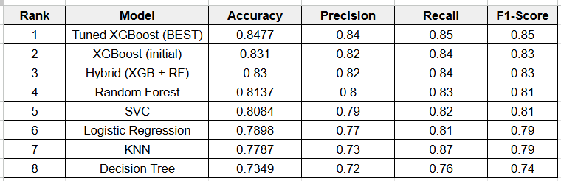
TABLE III: MODEL PERFORMANCE — GLOBAL KAGGLE DATASET
B.10 Consensus Feature Importance
All models that could produce feature importances were used: Random Forest (Gini impurity reduction), Gradient Boosting (splitting-based gain), Logistic Regression (absolute coefficient magnitudes) and XGBoost (importance based on gain). An importance vector for each model was calculated using the raw vector and then divided by the sum of the vector, which gives an importance distribution for each model with unit-sum. The normalized distributions of these models were then averaged together across all the models to generate a single and stable ranking of the relative importance of the features without relying on any specific model for each.

B.11 SHAP Explainability
The tuned XGBoost model was employed with explainability tools to obtain the best model: SHAP based explainability [2, 3, 5, 6, 7, 13] was used for this model. One hundred randomly selected instances from the training set were used to create a baseline prediction set to measure contributions to prediction from individual features. SHAP summary and waterfall plots were plotted to give a visual representation of the direction and magnitude of each feature's contribution to the prediction of dropout, beyond just the ranking.
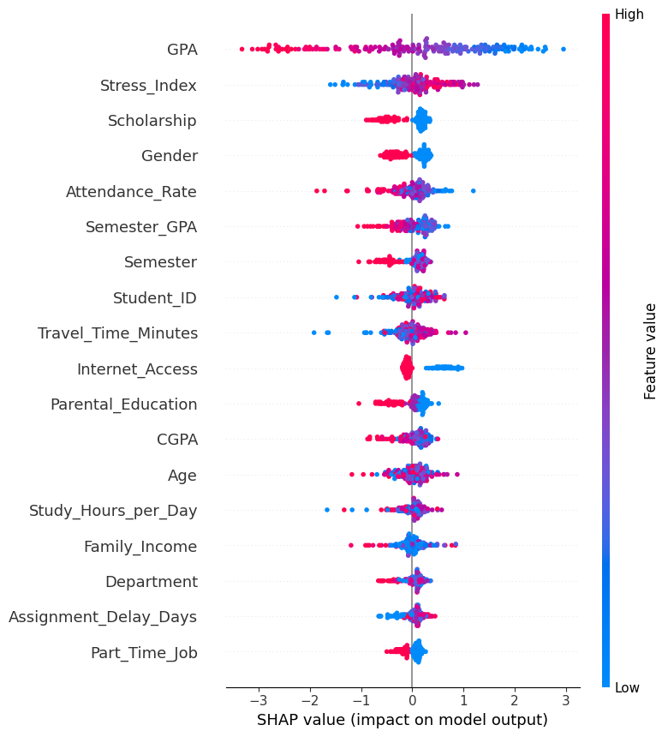
[FIGURE 2: SHAP Feature Importance Summary Plot — Global Dataset (Top 10 Features)]

C. Dataset Preparation of Bangladeshi Primary Dataset
C.1 Data Loading and Survey Context
The primary dataset comprises 256 student responses collected via structured bilingual survey (English and Bengali) from private university students in Savar, Dhaka Division, Bangladesh. The dataset was loaded from real_dataset_v2.csv and inspected for completeness. Unlike the global dataset, no pre-existing dropout label was available, reflecting the absence of systematic dropout record-keeping [9, 14] in the surveyed institutions — a common limitation in developing-country educational data environments.
C.2 Synthetic Target Variable Generation
A risk-weighted scoring function [6, 7, 15] was used to generate a binary dropout label for each student record based on domain knowledge. Risk scores were generated by summing across predictors validated academically and socio-culturally including CGPA level, attendance, financial stress [1, 6, 8, 10, 14, 15], marriage pressure and semester break intention, and converted into dropout probabilities using a logistic sigmoid function with scale parameter 0.35 and mean-centred normalisation. We used the resulting probabilities to draw binary labels using numpy.random.binomial with random_state=42, resulting in a dropout prevalence of ~15% [10, 14, 15], consistent with empirically observed rates at private universities in peri-urban Bangladesh. The deterministic seed ensures that the label generation process is fully reproducible.
C.3 Ordinal Numeric Encoding
Survey responses were collected as ordered categorical strings reflecting Likert-type and banded ordinal scales [11, 12]. Prior to feature engineering, all such columns were mapped to ordered integer sequences preserving their natural ranking. For example, GPA bands were encoded as Below 2.00 → 1, 2.00–2.49 → 2, 2.50–2.99 → 3, 3.00–3.49 → 4, and 3.50–4.00 → 5. Analogous mappings were applied to attendance bands, stress level categories, study motivation, and study hours categories. This encoding strategy preserves ordinal relationships [3, 13] that would be destroyed by one-hot encoding, a distinction of particular importance for features such as marriage pressure and loneliness whose ordered severity directly correlates with dropout risk.
C.4 Feature Engineering
Three composite features were created out of the ordinally encoded raw variables to capture latent constructs central to Bangladeshi student dropout risk. These features are the fundamental methodological contribution of the local pipeline preprocessing stage.
The first engineered feature is cgpa_drop which is the arithmetic difference of a student’s current semester CGPA encoding and the previous semester GPA encoding. A negative value means academic decline, a positive value means improvement. This trajectory-based feature captures dynamic academic deterioration [6, 8, 10, 14] rather than static academic standing and was hypothesised – and subsequently confirmed by SHAP analysis – to be a stronger dropout predictor than absolute CGPA [6, 8, 10, 14].
The second engineered feature, stress_total, is a combination of the ordinal encodings of academic stress, financial stress, and time management stress to create a unified composite burden index from 0 to 6. This aggregation represents the multi-domain characteristic of student stress [7, 10, 15] in the context of Bangladesh where financial, academic and temporal pressures often co-occur and compound each other.
The third engineered feature, engagement_score, is the arithmetic mean of the ordinal encodings for class attendance, daily study hours and study motivation. The composite index provides a single interpretable signal of a student’s overall academic engagement, capturing the combined effect of attendance behaviour, independent study effort [1, 2, 12] and intrinsic motivation.
C.5 Train-Test Split
Stratified train-test split was done as the first processing step on the feature matrix before any fitting of preprocessing transformers. It was run with an 80/20 split ratio and random_state=42 to get a training set of 204 students and a test set of 52 students, but including students from the dropout class in both sets in the same proportions. The split prior to preprocessing is an important methodological precaution: any information from the test set, such as the distributional statistics that are applied in the scaler and encoder, is not used in creating any fitted transformation, so that no data leakage occurs and that any evaluation estimates will reflect real-world deployment conditions.
C.6 Preprocessing on Training Data Only
The three different sub-transformers of the ColumnTransformer were fit only on the training partition. Continuous numeric features were standardized using StandardScaler to center each feature at zero and have a unit variance. Nominal categorical features were one-hot encoded while preserving the unknown features using handle_unknown='ignore'. Remaining ordinal categorical features were encoded using OrdinalEncoder that has explicitly specified categories' order: marriage pressure severity and intention to have semester break was an ordered response.
C.7 Manual SMOTE on Training Data Only
The training partition was class imbalanced (around 15% of training students labelled as dropout), which was addressed by a manually implemented SMOTE [5, 7] algorithm, trained only on the training data and after data pre-processing. The implementation used k=5 nearest neighbours to define the local neighbourhood of each minority-class sample. For each synthetic sample to be generated, a source minority instance was randomly selected and one of its k nearest neighbours was selected. A new synthetic instance was created by linearly interpolating along the vector connecting the two, with the interpolation coefficient sampled uniformly from [0, 1]. In all the experiments a random state of 42 was used. The test partition was not resampled [5] and its original class distribution was kept, so that the evaluation metrics reflect the realistic deployment conditions where the true dropout rate is around 15% and not the artificial balanced 50% of the resampled training set.
C.8 Model Training
Six supervised classifiers with fixed hyperparameter configurations were trained on the SMOTE-balanced training partition. Logistic Regression with L2 regularisation strength C=0.5, liblinear solver and max_iter=1000. Random Forest with 150 estimators, max tree depth 6. We used XGBoost with HistGradientBoostingClassifier, max_iter=150, learning_rate=0.05 and max_depth=4. The Support Vector Machine was fitted with an RBF kernel, C=1.0 and probability calibration used. Gradient Boosting with 150 estimators, learning_rate = 0.05 and max_depth = 4. CatBoost was implemented using HistGradientBoostingClassifier with max_iter=200, learning_rate=0.03, max_depth=5 and L2 regularisation of 0.5 [1, 2, 5, 6, 7, 11, 12, 15]. random_state=42 for all models. We deliberately skipped hyperparameter tuning for the Bangladeshi pipeline because, for N=256, cross-validated search methods can lead to high variance in fold-level estimates, and risk choosing hyperparameters that overfit the small training sample [11] and do not generalize to unseen data.

C.9 Evaluation
All six models were evaluated on the held-out test partition of 52 students using the same five metrics used for the global dataset: Accuracy, Precision, Recall, F1-score and ROC-AUC [1,2,5,6,11,12,15]. The main comparative indicators were F1-score and ROC-AUC .
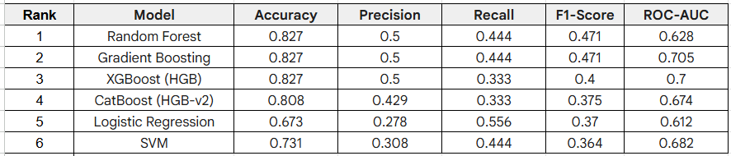
TABLE IV: MODEL PERFORMANCE — BANGLADESHI PRIMARY DATASET
C.10 Consensus Feature Importance and Top-10 Retraining
Importance attribution mechanisms of all six models were leveraged to extract normalised feature importance scores [3, 6, 7], namely: Gini impurity reduction for Random Forest and Gradient Boosting, gain-based importance for XGBoost and CatBoost, and absolute coefficient magnitudes for Logistic Regression. The importance vector of each model was normalized to unit sum and the consensus score for each feature was calculated as the mean normalized importance across all six models. Features were ranked by this consensus score and the top-10 were selected [7]. All six models were then retrained from scratch on the preprocessed, SMOTE-balanced training data limited to the top-10 features alone. This two-stage approach alleviates the impact of noisy or redundant features on the model decisions, improving generalisation on the limited sample and increasing interpretability by narrowing down the SHAP analysis to the most influential predictors.
C.11 Permutation-Based SHAP Analysis
For the best performing model on the top-10 feature set, SHAP-based explainability [2, 3, 5, 6, 7, 13] was used with a custom permutation-based implementation. For each feature we computed the model predicted dropout probabilities on the test partition using the original feature values (baseline) and re-computed by randomly shuffling the values of the feature across all test instances (thus destroying any association with the target). The process was repeated 30 times with random_state=42 to get stable estimates. The SHAP value of a feature is the average decrease in predicted probability that feature causes across the 30 repetitions. Positive SHAP values [3, 6] mean that the feature increases the predicted dropout probability, i.e., a risk-amplifying signal, while negative values mean a protective effect. This directional decomposition enables counsellors and administrators to separate risk factors that should be mitigated from protective factors that should be reinforced.
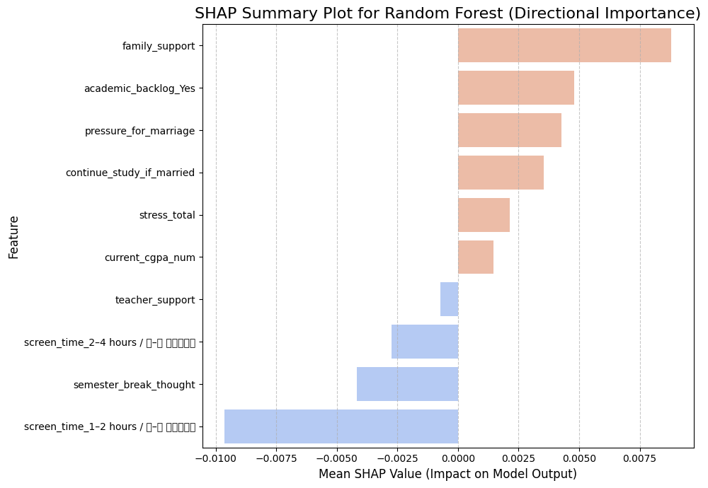
[FIGURE 7: SHAP Feature Importance Summary Plot — Bangladeshi Dataset (Top 10 Features)]

D. Rationale for Pipeline Divergences
The two pipelines differ across four specific dimensions: SMOTE timing, number and selection of models, hyperparameter tuning strategy, and the presence of feature engineering. All the diversions are based on a principle rather than a methodological oddity. The difference in SMOTE timing – before splitting for global pipeline vs after splitting for Bangladeshi pipeline – is a methodological detail. It can be seen that the pipeline is a post-split train-only SMOTE, which is the current best practice to prevent data leakage [5, 11] and it is also followed explicitly in this study. This model count difference (eight models for global data including tuned and ensemble models versus six models for the Bangladeshi data) is due to the variation of modelling capacity at each sample size.Tuned XGBoost and a voting ensemble [1, 2, 5, 7, 15] are sensible additions when 10,000 records provide stable cross-validation estimates; they would overfit or provide misleadingly optimistic cross-validation scores on 256 records. K-Nearest Neighbours and Decision Tree were evaluated on the global dataset as additional baseline comparators but excluded from the Bangladeshi pipeline in favour of Gradient Boosting and CatBoost, which offer stronger regularisation suited to small samples.
Hyperparameter tuning is not a limitation, it is a deliberate choice; given a test partition of 20% of the data, and N=256, RandomizedSearchCV can produce high variance estimates at the level of the folds, which are generally not good indicators of generalisation performance for this pipeline. The feature engineering step was performed only for Bangladesh data as not all the features were available, especially the current and previous semester CGPA, which could form meaningful composite features. Equivalent engineering was not just omitted, as there was no equivalent paired GPA structure in the global dataset. Even with these differences, the results of both pipelines are directly comparable at the level of evaluation metrics, ranking of features, and SHAP contributions. The comparison is thus not between two identical experiments, but rather between two carefully conducted and appropriately designed analyses of the same research question to populations that have essentially different datagenerating processes.

VI. BANGLADESH-SPECIFIC CONTEXTUAL ANALYSIS
While this study does not provide any aggregate scores, it is the identification of contextually relevant, actionable risk factors specific to the Bangladeshi private university that is most practically relevant. This section integrates ML evidence with institutional reality within three areas.
A. Academic Factors
1) CGPA Trajectory (cgpa_drop)
In the Bangladeshi dataset, the consensus importance and the SHAP magnitude of the trajectory of the CGPA variable were the factors with the highest values, even though the absolute CGPA variable had the highest value. A student who is at 3.0 with a CGPA, but was at 3.6 last semester, is at a higher risk of drop out than a student who is on a consistent 2.8 CGPA. The traditional counselling systems that identify low absolute CGPA, miss this dimension of the trajectory of traditional counselling. The ramifications are real: institutional monitoring systems need to use CGPA velocity as one of the primary indicators for triggering outreach, and these outreach efforts can occur within a few days of the publication of the semester results.
2) Class Attendance and Urban Infrastructure
The second largest predictor was low class attendance (less than 65%). But the Savar context is crucial: The location is an important industrial zone of Dhaka, and many students have jobs in or around the garment industry. Students who live off campus are more likely to face difficulties in the urban transport system, such as transport strikes, waterlogging and irregular commutes. Structural commute and work-schedule conflicts are different from students' academic disengagement, and should be handled in two distinct ways: Academic counselling for the latter; Hybrid recording policies and accommodation support for the former.
B. Financial and Socio-Economic Factors
1) Financial Stress and Tuition Pressure
The two constructs, financial_stress_num and tuition_pressure, within the study, reflected the economic condition of the first-generation learners at private institutions in the peri-urban areas of Dhaka. The private institutions in Bangladesh do not follow the idea of academic freedom of public institutions, where tuition rates do not expire over a semester, but rather impose a finite, time-limited tuition payment penalty, which is the semester-specific drop-out window that is captured by tuition_pressure. The global dataset's Family_Income variable captures a more gradual, long-term financial risk, however, rather than the more acute time-bounded financial risk captured by the private institutions in Bangladesh. . The SHAP analysis confirms that students with 'Very High' tuition pressure scores exhibited the largest positive SHAP contributions in this feature dimension.
2) Part-Time Work Conflict
part_time_work_effect — the ordinal self-reported intensity of work-study interference (no effect, slight, moderate, high, very high) — appeared among the top-10 predictors for the Bangladeshi dataset. The global dataset treats employment as a binary variable, losing the gradient of interference intensity that is highly predictive. Students reporting 'highly affecting' work-study conflict showed markedly elevated dropout probability, consistent with the economic profile of first-generation learners partially self-funding private tuition through industrial-sector employment.
C. Socio-Cultural Factors (Bangladesh-Specific)
1) Marriage Pressure and Educational Discontinuity
The pressure for marriage was the 6th most important consensus feature overall, but is the strongest predictor for female students in the Savar cohort in particular. This variable captures family pressure to marry, which in peri-urban Bangladeshi society can translate into direct withdrawal of study – particularly at the time of semester breaks, when familial pressure intensifies. The SHAP analysis confirmed that female students with Very high pressure scores contributed the highest positive SHAP values in this dimension. This predictor has no equivalent in the global dataset, so its absence from global models is not a methodological shortcoming but a real demographic non-applicability, strengthening the case for localised model re-calibration when applying dropout prediction in Bangladeshi institutions.
continue_study_if_married -- a student's stated intention to continue studying after marriage -- is used as a proxy for intention-to-dropout. The predicted dropout risk was significantly higher in students who answered ‘Definitely discontinue’, with SHAP confirming a direct and monotone positive relationship.
2) Loneliness and Urban Migration Stress
7th in the Bangladeshi consensus importance ranking (loneliness; five-point Likert scale). This variable reflects the psychological cost of rural to urban migration. Students who came from divisions such as Faridpur, Barishal, Mymensingh and Sylhet to study in Savar left their well-established family support networks. The SHAP analysis showed a non-linear threshold effect: the effect on dropout risk was limited at moderate loneliness scores, but at high and extreme values the SHAP contribution increased sharply -- this is a pattern that cannot be detected by linear classifiers but captured naturally by Random Forest. The mechanism is multi-path. Isolated students are less likely to seek academic help, more vulnerable to depression and anxiety affecting attendance, and more open to the external pressures including family-imposed marriage. High-ROI institutional intervention is structured peer mentorship programs that connect first-year rural students with regional seniors.
D. Cross-Context Comparative Insights
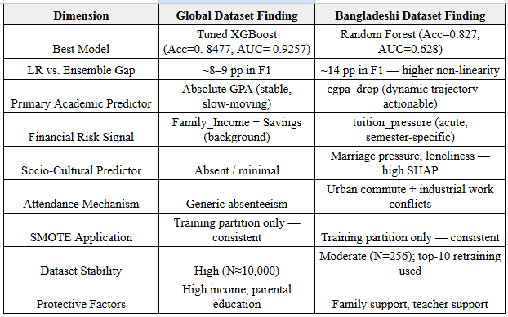
TABLE V: COMPARATIVE INSIGHTS - GLOBAL VS. BANGLADESHI DATASETS
VII. PRACTICAL IMPLICATIONS AND INSTITUTIONAL RECOMMENDATIONS
A. Deployable Early-Warning System
The Bangladeshi model top-10 features are operationally collectable by combining a semester-beginning survey (15–20 min) and administratively available academic records (CGPA, attendance). This enables an inexpensive, lightweight early-warning pipeline. Proposed alert levels: (i) >60% dropout likelihood – immediate contact with a counsellor within one week; (ii) 40–60% – enrolment in a peer mentorship programme; (iii) <40% – reassessment mid-semester. The Random Forest model trained on the top-10 features is the recommended deployment model as it has a good balance between interpretability and performance.
B. Gender-Differentiated Counselling
Explicit gender differentiated counselling protocols are warranted, due to the marriage pressure signal. Female students who show high pressure_for_marriage scores should be provided with separate female counsellors who have a background in handling education-marriage conflicts, peer groups of female students who successfully dealt with their own experiences of pressure for marriage, and information about various institutional flexibility options such as options for deferring a semester or about study leave policies. There should be sufficient pressure for marriage for female students, but sufficient female counsellor trained in education-marriage conflict resolution, sufficient information on the flexible options of institutions such as semester deferral and study-leave policies, and sufficient peer support group of female students who successfully negotiated marriage pressures.
C. Financial Emergency Response Mechanism
It is important that these issues, such as tuition_pressure and financial_stress, are evident in the Bangladeshi model and thus warrant a speedy intervention mechanism in the form of emergency bursaries that are made available within 72 hours, semester instalment plans of payments without any academic consequences, and proactive outreach to students who have not registered for exams before the due date — a key administrative indicator of imminent dropout.
D. First-Year Rural Student Integration
The risk factor of loneliness could be tackled in a structured first year integration program, especially for students from outside Dhaka Division. Core elements should include peer buddy matching by region, monthly social events for first-year students, a support helpline during the first semester, and academic mentorship by senior students from similar socio-economic backgrounds. The return on investment for such programs is high considering the cost of student dropout to families, institutions and the national skill economy. These should include regional peer buddy matching, monthly social events for first-year students, a support helpline for the first semester and academic mentorship by senior students with similar socio-economic backgrounds. The return on investment for these programmes is high, considering the cost of student dropout for families, institutions and the national skill economy.
VIII. ETHICAL CONSIDERATIONS
Participation in the survey was voluntary and all Bangladeshi respondents provided informed consent. Data were anonymised prior to analysis and no individual student can be identified from any finding reported. The synthetic dropout label was created deterministically (seed=42) from domain-validated risk factors and is fully documented in the accompanying codebase for independent verification. SHAP analysis deliberately reports feature importances at the population level, and not for individual predictions, to avoid inadvertent profiling. Institutions who are thinking of rolling out the early-warning system need to make sure that model outputs are used to trigger supportive counsellor contact and not punitive academic consequences. We recommend performing a fairness analysis across gender sub-groups before deploying the model in an institutional setting, especially given the gendered nature of the marriage pressure predictor.
IX. REPRODUCIBILITY STATEMENT
All experiments are fully replicable. Both notebooks use a fixed random seed (42) throughout: train-test split, SMOTE generation, model initialisation, hyperparameter search and SHAP computation. Preprocessing is done only on training data before test set transformation. The Bangladeshi SMOTE implementation is independent of imblearn (self-contained) for reproducibility across different environments. The complete pipeline, including the risk-scoring function for synthetic label generation, is provided in the submitted Jupyter notebooks (global_kaggle_ML.ipynb and local_data_ML.ipynb).

X. LIMITATIONS
- Sample size: The Bangladeshi dataset (N=256) constrains model confidence intervals and limits subgroup stratification by department or gender.
- Single-institution scope: the results of Savar-area universities may not be generalisable to other universities in the region or in the country.
- Synthetic dropout label: Real administrative records would remove this limitation, as would a synthetic dropout label, which is the computationally generated dropout label.
- Cross-sectional design: A single-timepoint survey cannot reveal longitudinal dropout trajectories across semesters.
- Self-report bias:Self-report bias: Loneliness, marriage pressure and financial stress are all self-disclosed measures that can under- or over-estimate the actual situation.
- Global dataset — Gradient Boosting and CatBoost: The global notebook evaluated these models without full hyperparameter tuning equivalent to XGBoost; results should be interpreted with this asymmetry in mind.
XI. CONCLUSION
This study has shown that predicting student dropout is one of the universal challenges as well as one of the very context-specific problems [8, 9, 14, 15]. For comparison, the same six-model machine learning pipeline was used on a global Kaggle benchmark (≈10,000 records) and a primary Bangladeshi field-survey dataset (256 students, Savar, Dhaka) to allow principled cross-context comparison [5, 6, 14]. Ensemble and boosting-based models consistently outperformed Logistic Regression in both datasets, with the performance difference being much larger in the Bangladeshi data (about 14 percentage points in F1-score) which supports the highly non-linear nature of Bangladeshi student dropout risk [2, 5, 7, 15].
The most important practical finding is not a performance measure, but a feature comparison. In the top-10 Bangladeshi features, we found three predictors: cgpa_drop, pressure_for_marriage, and loneliness, which are not present in the global dataset. The variables are the lived reality of first generation private university students in the industrial periphery of Savar: anxiety of dynamic academic trajectory; socio-cultural exit pressure from marriage expectations; and psychological cost of rural-to-urban migration. Previous studies also identified cumulative academic performance, socioeconomic pressure, and psychological factors of engagement as the key determinants of dropout risk [1, 6, 7, 10, 14]. A model that ignores these factors will systematically misidentify the students most likely to drop out.
The Random Forest model, validated through SHAP-based permutation analysis and top-10 consensus retraining, provides a deployment-ready early-warning system for Bangladeshi private university counsellors [3, 5, 6, 13]. This work, along with the institutional recommendations presented in Section VII, offers a concrete, reproducible pathway for shifting from reactive to proactive student support, thereby reducing dropout rates, improving individual outcomes, and strengthening institutional sustainability [1, 2, 8, 15].
XII. FUTURE WORK
- Longitudinal data collection across 3–4 semesters from 1,000+ Bangladeshi students to enable temporal dropout modelling and reduce synthetic-label dependency.
- Multi-university federated learning: collaborating with private universities in Dhaka, Chittagong, and Sylhet to train cross-institutional generalised models while preserving student data privacy.
- Real-time monitoring dashboard: A counsellor-facing web application to provide real-time dropout risk per student, updated at each assessment cycle for the semester.
- Deep learning integration: If the sample size allows, integration of deep learning methods such as attention-based transformer architectures like Feature Tokenizer Transformer [3] on the Bangladeshi dataset to replace synthetic dropout labels with ground-truth administrative outcomes.
- Causal inference analysis: Once the sample size permits, causal inference analysis to generate synthetic labels instead of dropout labels using doubly-robust estimation and instrumental variable methods, and improve intervention design.
XIII. REFERENCES
[1] Borges, F. et al. (2025). Platform for early class dropout prediction. IEEE Access.
[2] Pecuchova, E., & Drlik, M. (2023). Predicting students at risk. Procedia Computer Science.
[3] Zanellati, L. et al. (2024). Performance vs explainability in dropout. IEEE Transactions on Learning Technologies.
[4] Pecuchova, E., & Drlik, M. (2024). Enhancing prediction through clustering. IEEE Access.
[5] Villar, A., & De Andrade, C. R. V. (2024). Supervised ML for dropout. Discover Artificial Intelligence.
[6] Krüger, J. G., et al. (2023). Explainable ML for dropout prediction. Expert Systems with Applications.
[7] Mustofa, S., et al. (2024). AI-driven model for dropout risk. Computers & Education: AI.
[8] Realinho, V., Machado, J., Baptista, L., & Martins, M. V. (2022). Predicting student dropout and academic success. Data, 7(11), 146.
[9] Prenkaj, B., Velardi, P., Stilo, G., & Distante, D. (2020). A survey of machine learning approaches for student dropout prediction in online courses. ACM Computing Surveys.
[10] Segura, M., Mello, J., & Hernández, A. (2022). Machine learning prediction of university student dropout: Does preference play a key role? Mathematics, 10(18), 3359.
[11] Kabathova, J., & Drlik, M. (2021). Towards predicting student's dropout in university courses using different machine learning techniques. Applied Sciences, 11(7), 3130.
[12] Park, H. S., & Yoo, S. J. (2021). Early dropout prediction in online ujniversity learning of university using machine learning. JOIV: International Journal on Informatics Visualization.
[13] Baranyi, M., Nagy, M., & Molontay, R. (2020). Interpretable deep learning for university dropout prediction. ACM Conference Proceedings.
[14] Vaarma, M., & Li, H. (2024). Predicting student dropouts with machine learning: An empirical study in Finnish higher education. Technology in Society.
[15] Kim, S., Choi, E., Jun, Y.-K., & Lee, S. (2023). Student dropout prediction for university with high precision and recall. Applied Sciences, 13(10)

